1. Launch one ec2 using Amazon Linux 2 image and add script in user data to install Apache.

=>first create one instanse in ec2 with amazon linux image

=> while creating add script to install apache in discription.

=>then launch instance

=>go to browser and search ip4 address with port 80

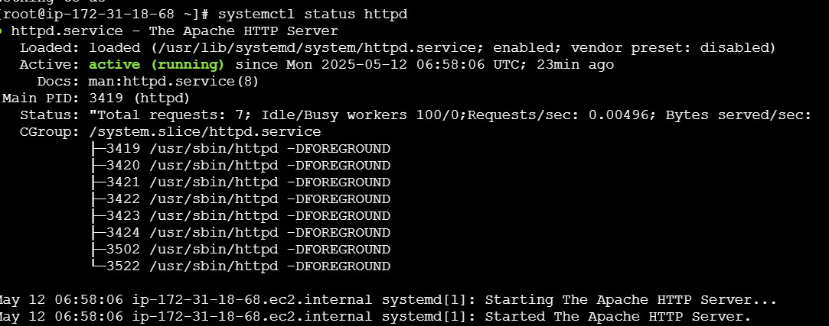

1. Launch one ec2 using Ubuntu image and add script in user data to install Nginx.

=>first create one instanse in ec2 with ubuntu image

=> while creating add script to install nginx in discription.

In user data section , enter the following script

#!/bin/bash apt update -y apt install -y nginx systemctl start nginx systemctl enable nginx echo "Nginx installed and running" =>then launch instance.

=>go to browser and search ip4 address with port 80

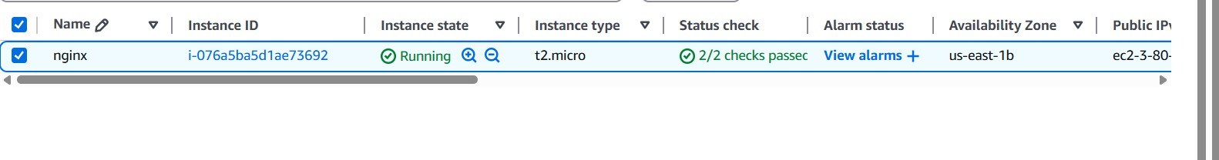

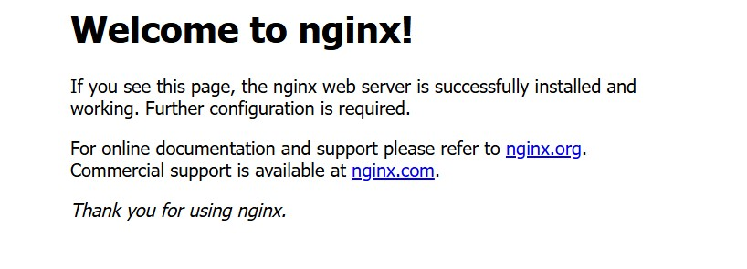

1. Launch one windows server and install tomcat in windows.

Launch one windows server and install tomcat in windows.

**Part 1: Launch a Windows Server (on AWS)**

**Step 1: Log in to AWS Console**

1. Go to <https://console.aws.amazon.com>
2. Sign in with your AWS credentials.

**Step 2: Launch EC2 Instance**

1. Navigate to **EC2 > Instances > Launch instance**.
2. Fill in:
   * **Name**: Windows-Tomcat-Server
   * **AMI (Amazon Machine Image)**: Choose Microsoft Windows Server 2019 Base or later.
   * **Instance type**: Choose t2.medium or higher (Tomcat needs at least 2 GB RAM).
   * **Key pair**: Create/download a .pem file to access the instance via RDP.
   * **Security Group**:
     + Allow RDP (port 3389) for remote desktop.
     + Allow HTTP (port 80) and optionally port 8080 (Tomcat default).
3. Click **Launch Instance**.

**Step 3: Connect via RDP**

1. Once instance is running, select it and click **Connect > RDP client**.
2. Download the .rdp file and decrypt the Windows password using your key pair.
3. Use **Remote Desktop Connection** on your local PC to log in.

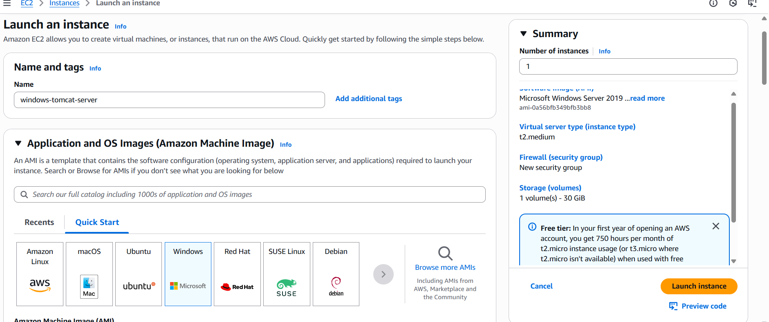

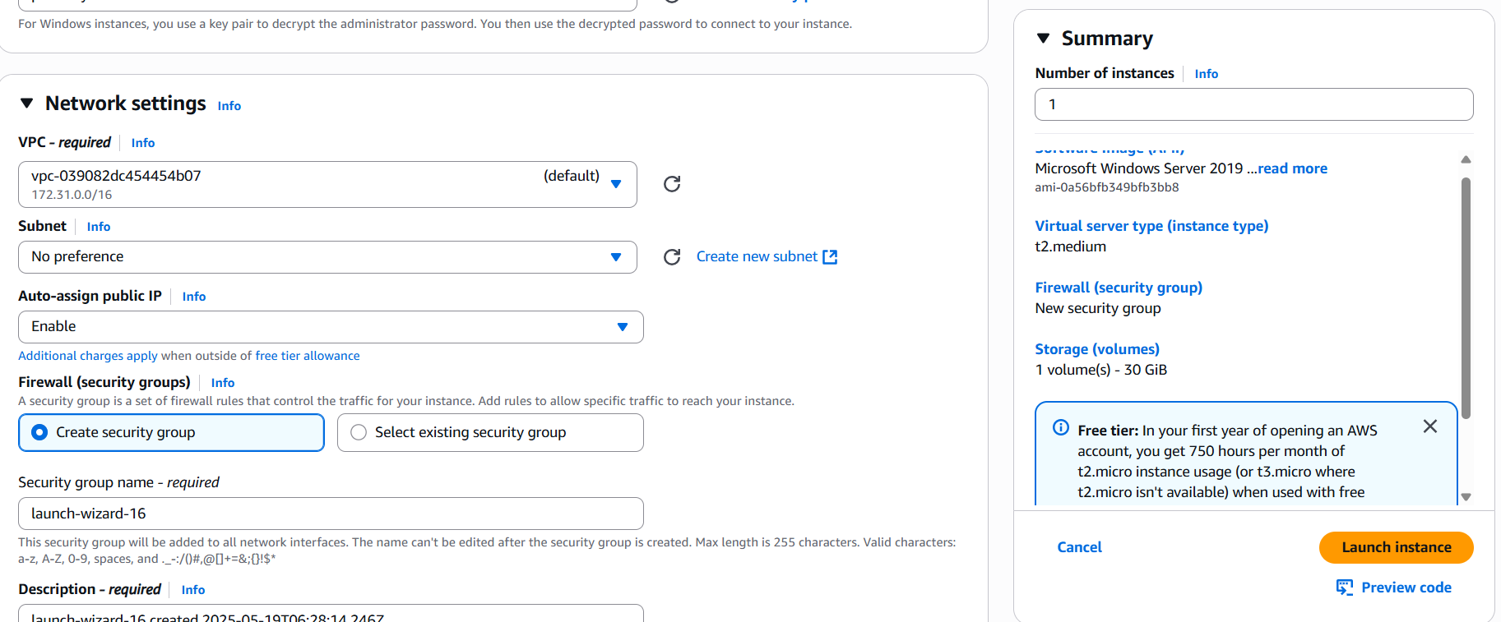

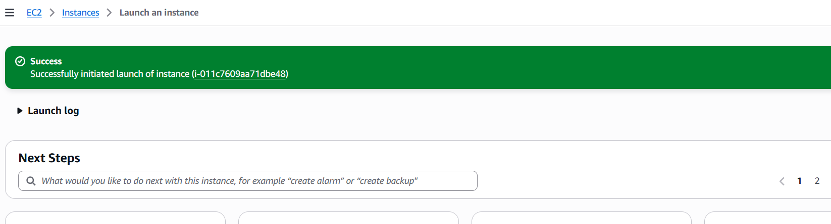

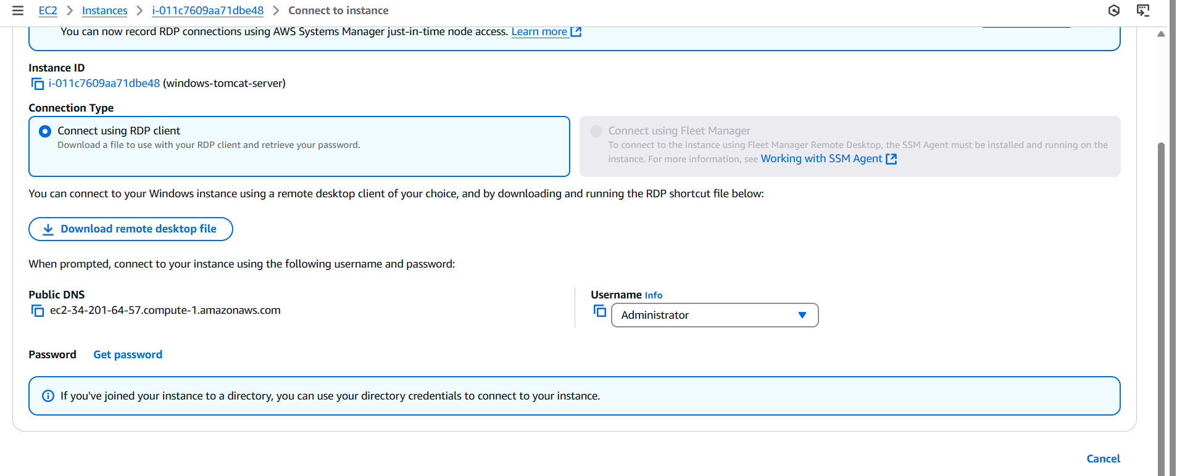

Click on the “Get password” button and you will get the below screenshot:

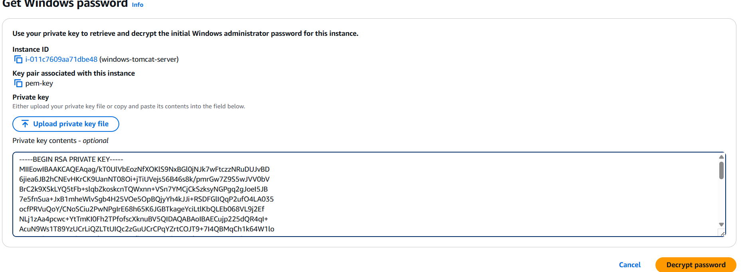

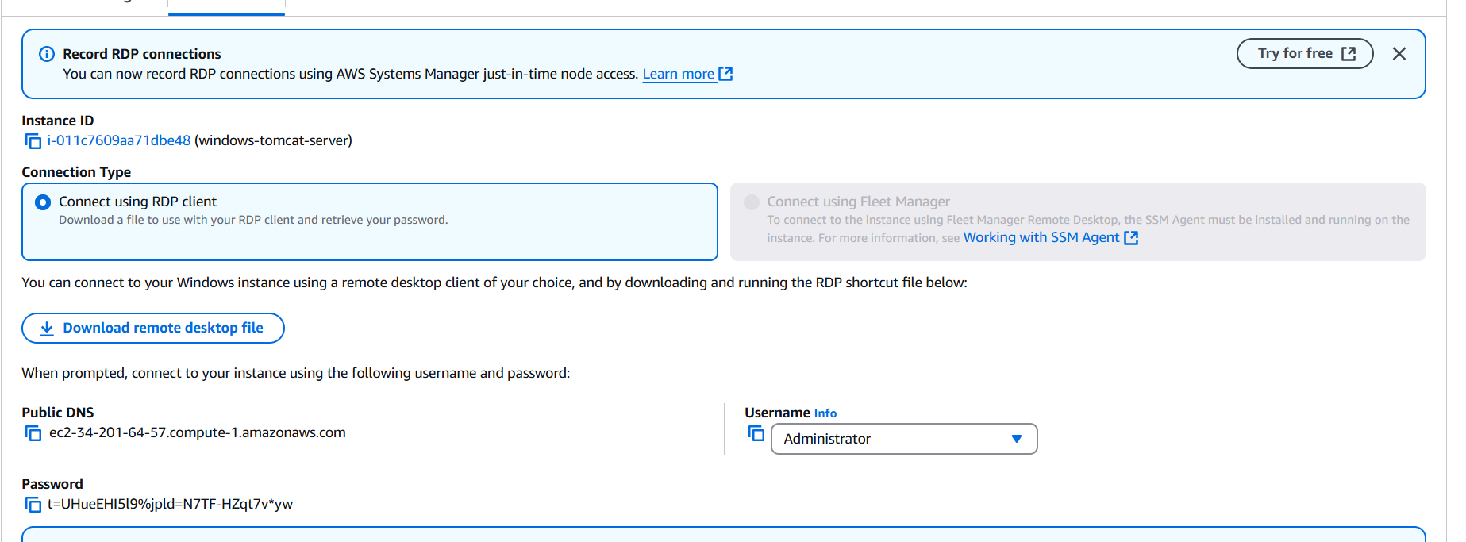

Go to the window client machine and run the “remote desktop file.exe” by double click on it:

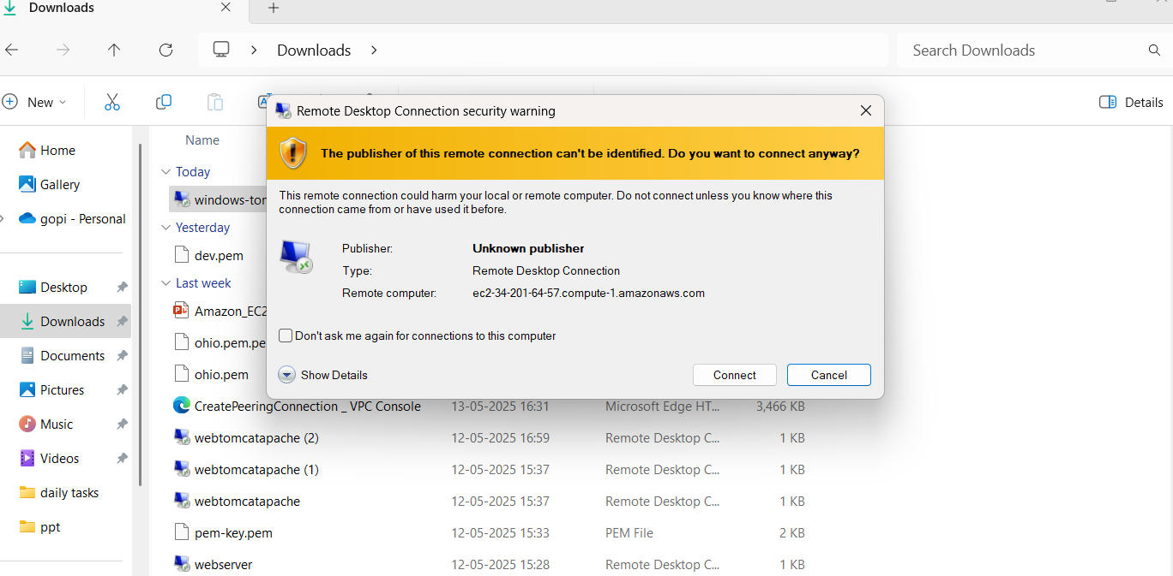

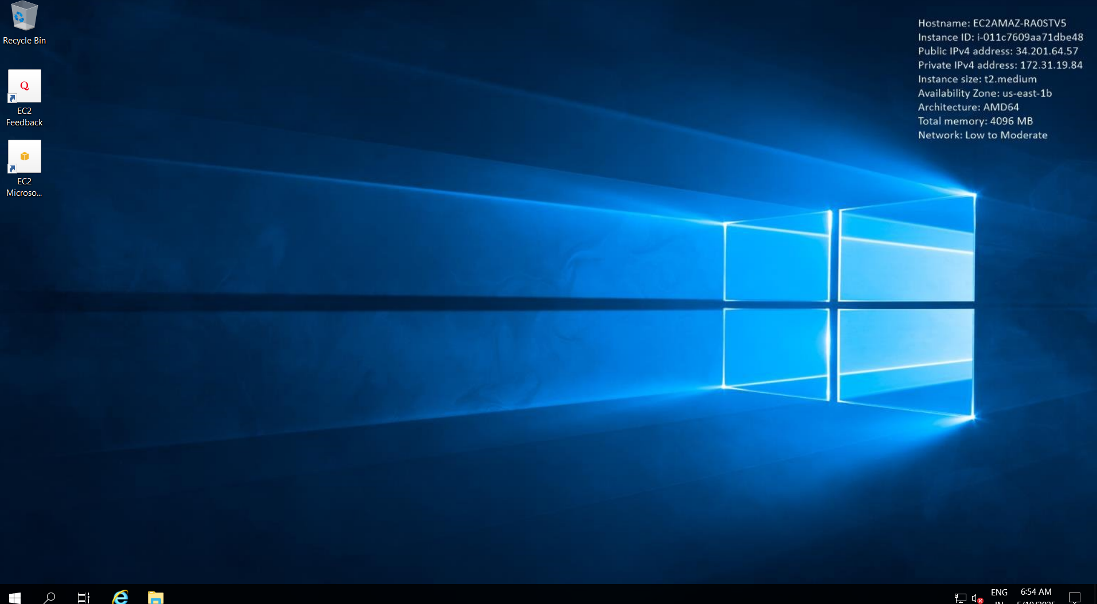

**Part 2: Install Java (Prerequisite for Tomcat)**

**Step 1: Download Java**

1. Open a browser in your Windows Server.
2. Go to the official Java SE page:  
   <https://www.oracle.com/java/technologies/javase-downloads.html>
3. Download **Java SE Development Kit (JDK)**, preferably JDK 17 or later.
4. Install it with default options.

**Step 2: Set Environment Variables**

1. Open **System Properties** > **Environment Variables**.
2. Under **System variables**:
   * Add a new variable:
     + **Name**: JAVA_HOME
     + **Value**: Path to JDK, e.g., C:\Program Files\Java\jdk-17
   * Edit the Path variable and add:  
     %JAVA_HOME%\bin
3. Open **Command Prompt**, run java -version to confirm Java is installed.

Downloading the java from this link, as shown in the below screenshot:

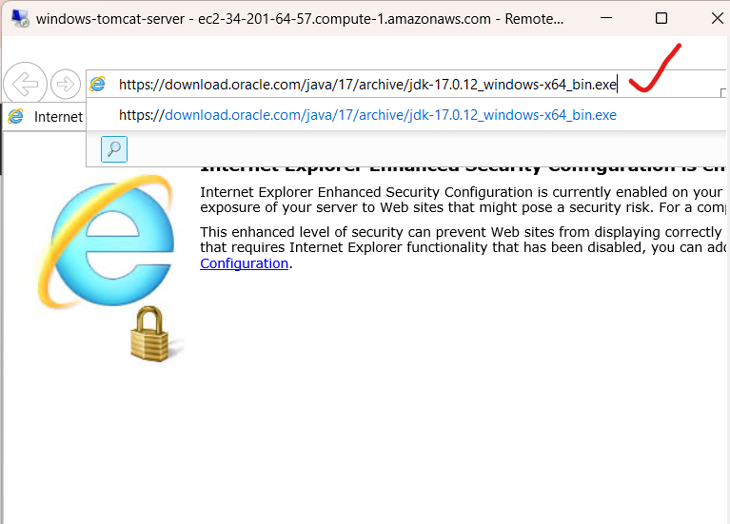

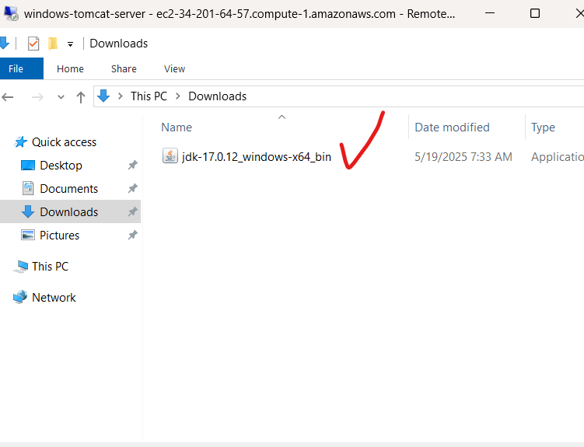

Installing the java:

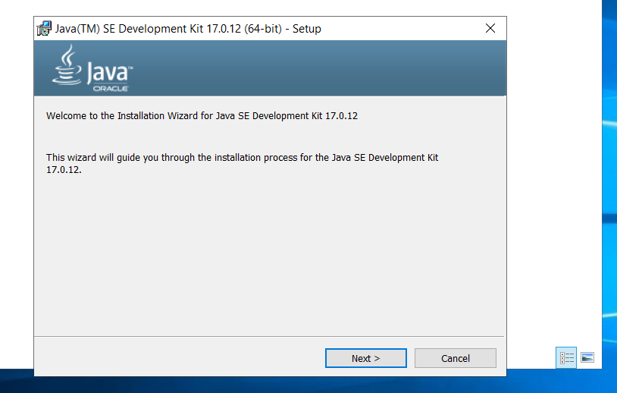

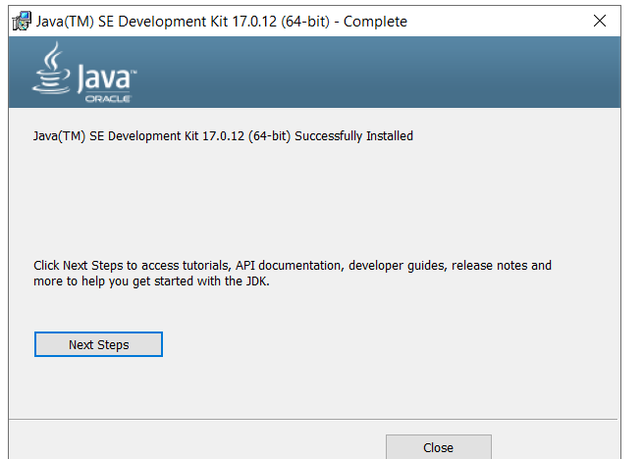

To check whether the java is installed or not: shown in the below screenshot

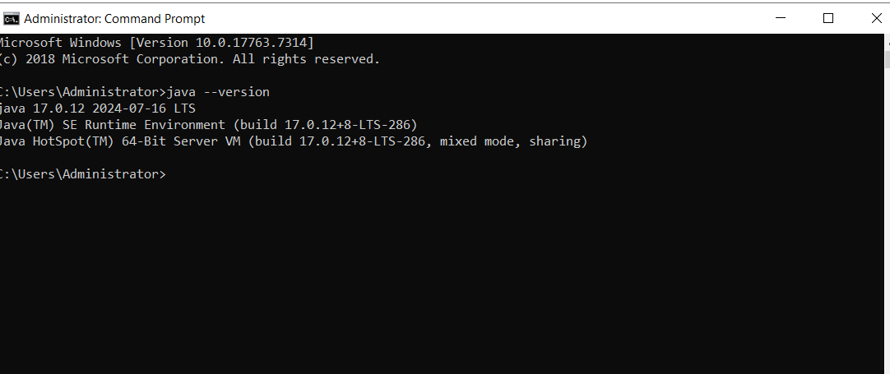

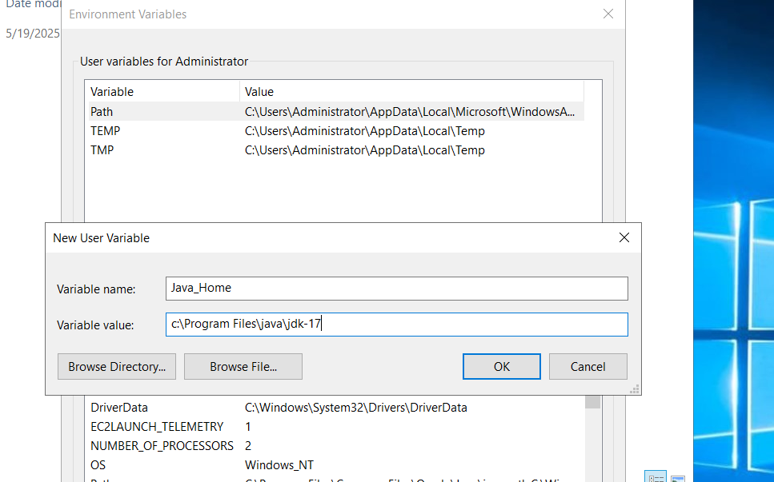

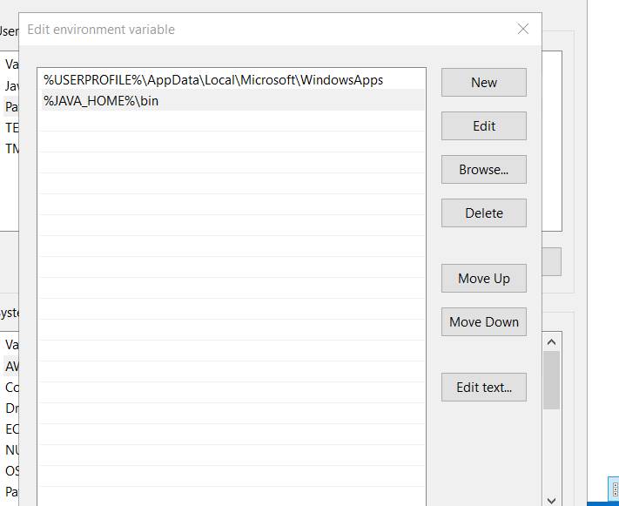

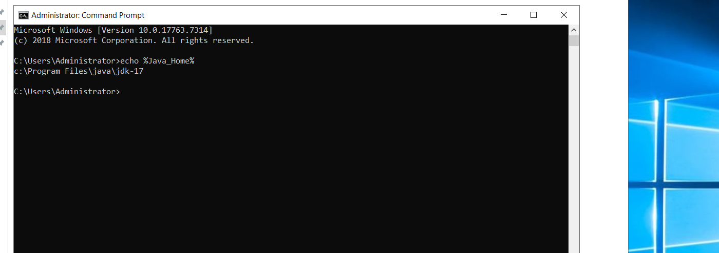

**Part 3: Download and Install Apache Tomcat**

**Step 1: Download Tomcat**

1. Visit the official site:  
   <https://tomcat.apache.org>
2. Choose the latest version (e.g., Tomcat 10 or 9).
3. Download the **32-bit/64-bit Windows Service Installer (.exe)**.

**Step 2: Install Tomcat**

1. Run the installer.
2. During installation:
   * Set **Tomcat admin username and password**.
   * Choose the installed **Java path** (installer usually auto-detects).
   * Set HTTP connector port (default: 8080).
   * Complete the installation.

**Step 3: Start Tomcat**

1. Tomcat installs as a Windows Service. You can manage it from:
   * Start Menu > Apache Tomcat > Monitor Tomcat
   * Or services.msc under **Apache Tomcat**.
2. Start the service if not already running.

**Step 4: Verify**

1. Open browser: http://localhost:8080
2. You should see the Tomcat welcome page.

To access from outside:

* Use http://<your-public-ec2-IP>:8080
* Ensure **port 8080 is open** in the EC2 Security Group.

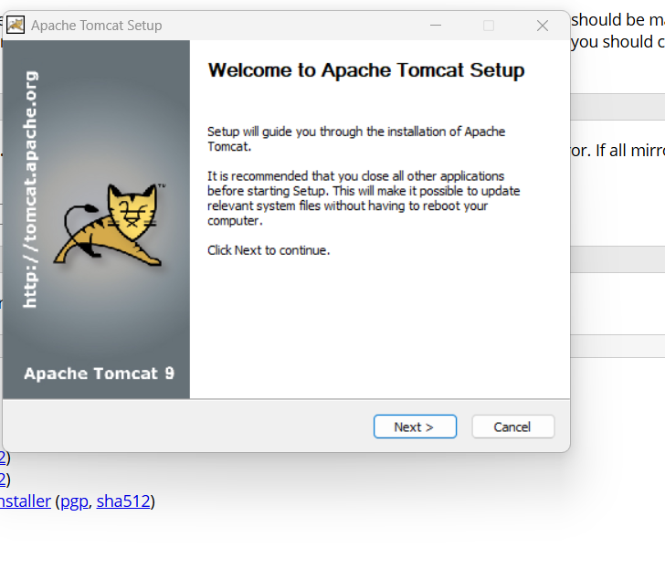

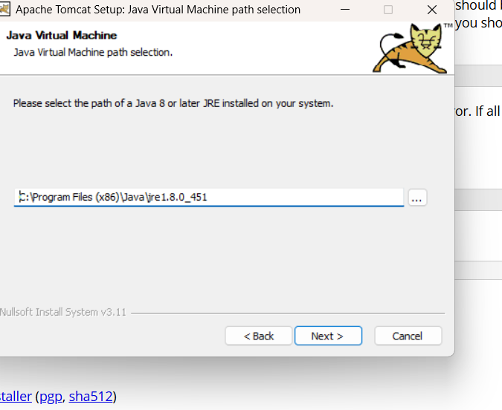

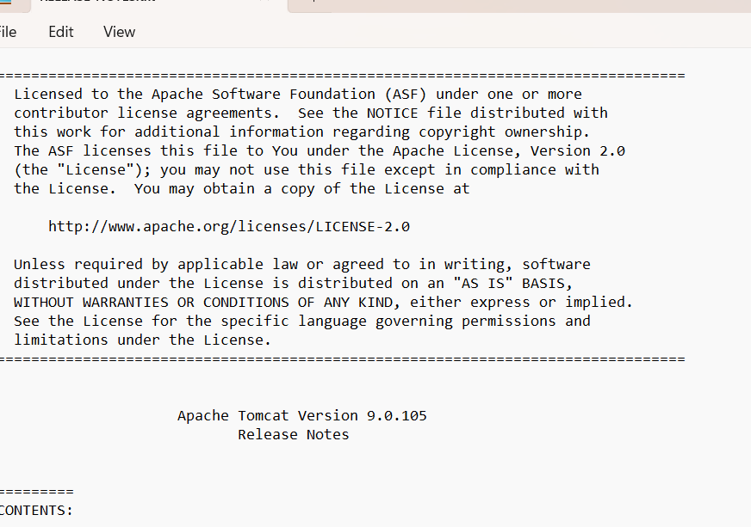

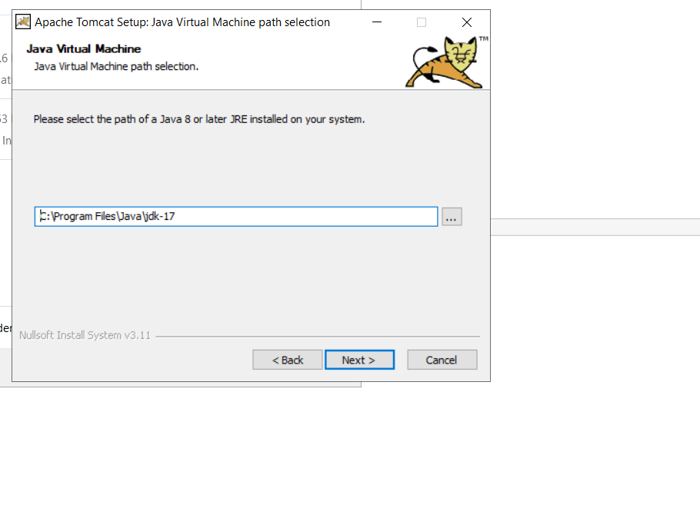

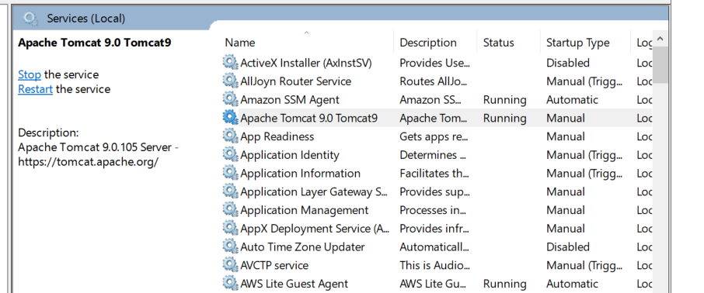

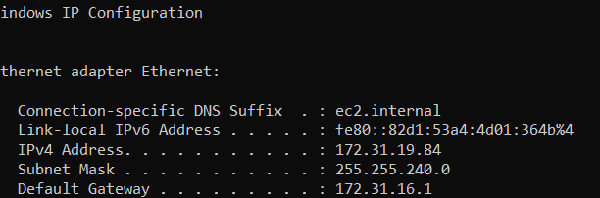

1. Take snapshot of the instance created in Task 1.

•Creating an EBS Snapshot (if your instance has a dedicated EBS volume for httpd data):

•Open the AWS EC2 console.

•Navigate to Volumes under Elastic Block Store (EBS).

•Select the volume attached to your instance.

•Click on Actions → Create Snapshot.

•Creating an Amazon Machine Image (AMI) (to save the entire instance state):

•Go to EC2 instances in the AWS console.

•Select your instance.

•Click Actions → Create image.

•Provide a name and description.

•Choose the necessary storage configurations.

•Click Create Image

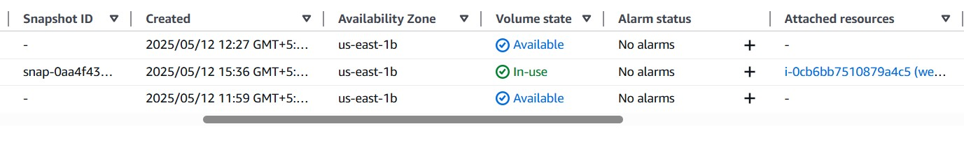

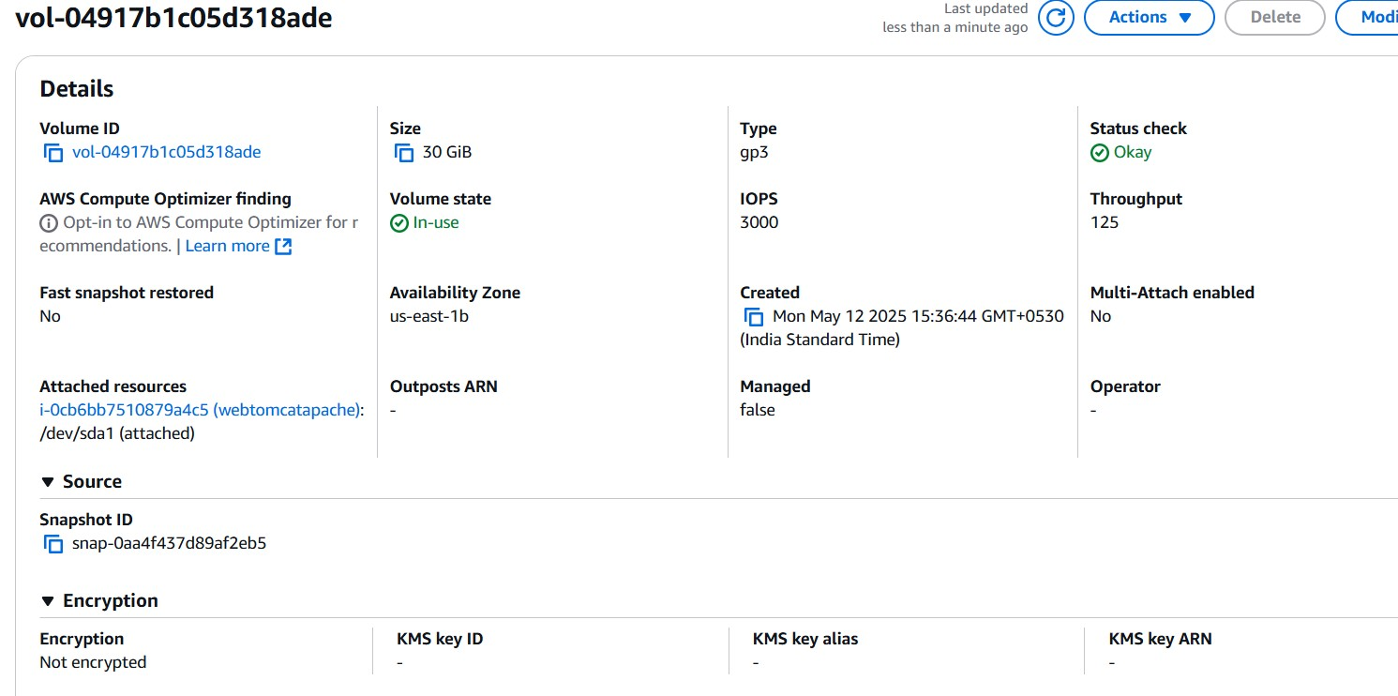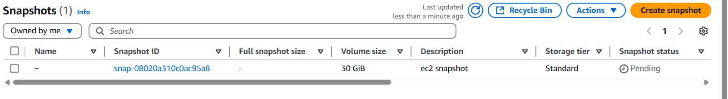

5) Assign password less authentication for ec2 created on Task 2.

* create a public key pair using ssh-keygen on the local system ● got to its location and copy the public key
* ssh into the instance and add the public key to the authorized_keys on that ec2 instance, save and quit.
* also change the authorized key permission to 600.
* exit from the instance and now log in to the instance using local machine by ssh ubuntu@<public-ip>
* If it works without asking for a password or pem key file then we have successfully set up password-less authentication

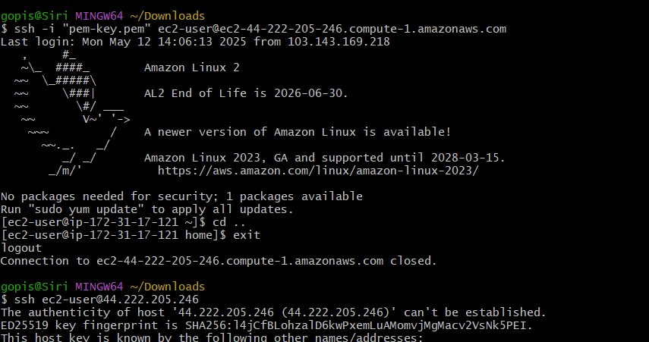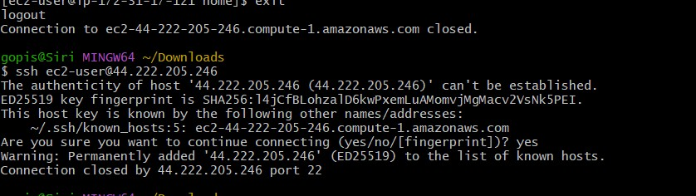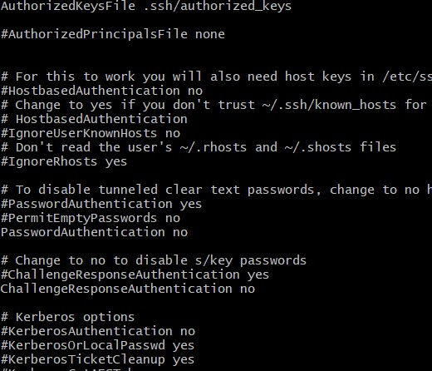

6) Launch any ec2 using spot purchasing option.

In the EC2 Dashboard, click “Launch Instance”

Name: Enter any name

Application and OS Images (AMI): Choose your desired AMI

Instance type: Choose your desired type Key pair : Choose or create a key pair Under "Advanced Details":

Expand the "Advanced Details" section.

Scroll to "Purchasing option"

Check the box that says "Request Spot Instances"

1. Configure storage and security group:

Storage: Leave defaults or modify

Security group: Use existing or create a new one

1. Click “Launch Instance”

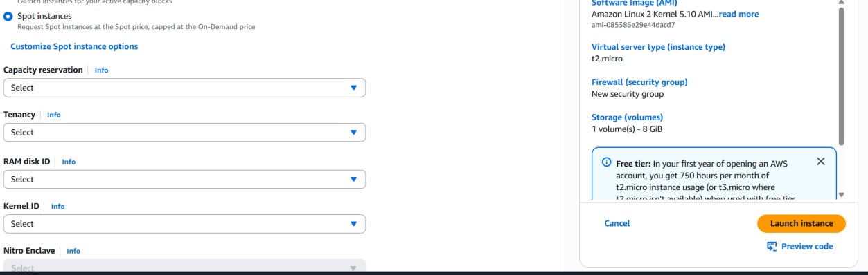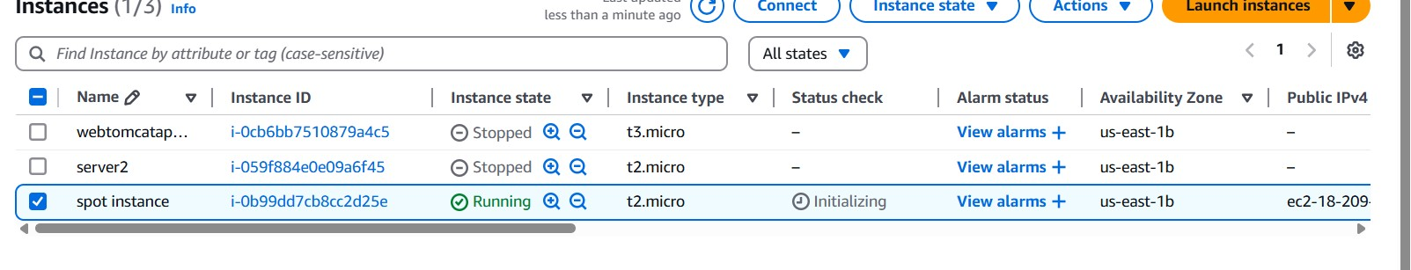

1. Enable Termination policy on ec2 created in Task 2.

=>select the server then click on action.

=>then go to instatnce settings.there we have to click on enable checkbox and save it.

=>then if we try to terminate proccess it will not allow us to terminate

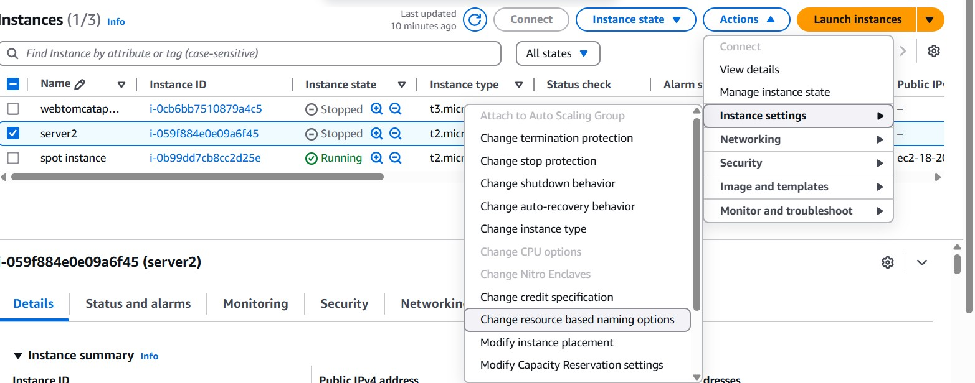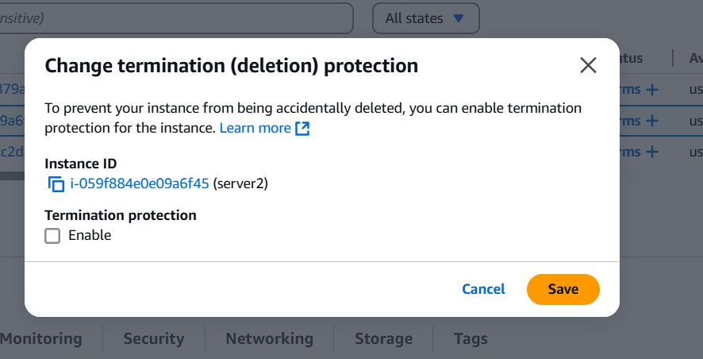

1. Launch one ec2 using Aws CLI.
2. Download AWS CLI from their(windows) website and  
   install  
   --Go to AWS account and open account top Left side  
   ->click on security credentials  
   --Scroll down we can see access key click on create  
   access key  
   --Access key and Security access key is generated  
   --Open Git bash type aws --version  
   --Aws configuration give access key and security access  
   key  
   --aws ec2 run-instances command is used to launch a  
   new EC2 instance — think of it as telling AWS,  
   “Create a virtual machine with these specific settings.  
   --Get ami id,sg id and subnet id from ani of instance  
   --aws ec2 run-instances \

